**Simultaneous Confidence Interval Methods for Analytical Similarity Assessment**

Jiayin Zheng1, Donglei Yin2, Mengdie Yuan3, Shein-Chung Chow3

1Biostatistics Program, Public Health Sciences, Fred Hutchinson Cancer Research Center,

1100 Fairview Ave N, Seattle, WA 98109, USA.

2Department of Applied Mathematics and Statistics, Stony Brook University,

100 Nicolls Road, Stony Brook, NY 11794, USA.

3Office of Biostatistics, Center for Drug Evaluation and Research,

U.S. Food and Drug Administration,

10903 New Hampshire Avenue, Silver Spring, MD 20993, USA.

**1 Background**

When an innovative biological drug product is going off patent protection, biotechnology and/or pharmaceutical companies (sponsors) may seek regulatory approval for similar biological (biosimilar) products to the innovative product in European Union (through EMA) or the United States (through FDA). Thus, for assessment of biosimilarity between a proposed biosimilar product (test product) and an innovative biological product (reference product), there may be multiple references, e.g., a US-licensed reference product and a EU-approved reference product of the same product. When there are multiple references, the sponsors often obtain extensive analytical data intended not only to support a demonstration that the proposed biosimilar product and the US-licensed reference product are highly similar, but also to provide a justification of the relevance of the comparative data (e.g., pharmacokinetic and/or clinical data) generated using EU-approved reference to support a demonstration of biosimilarity of the proposed biosimilar product to the US-licensed reference product.

In practice, however, the following questions often encountered. Suppose there are two reference products: a US-licensed reference product and an EU-approved reference product. First, we may successfully demonstrate the proposed biosimilar product is highly similar to each of the two reference products, but fail to demonstrate that the two reference products are highly similar. Second, we are able to demonstrate that the proposed biosimilar product is highly similar to one of the two reference products but not the other. Third, it is an interesting question whether the two reference products should be combined (e.g., taking the average or adjust for their corresponding variability associated with the responses) for an overall biosimilarity assessment. To address the first two questions, the method of pairwise comparisons in conjunction with a head-to-head graphical comparison is often considered. For the third question, Kang and Chow (2013) proposed a three-arm study design for biosimilarity assessment under a various scenarios of criteria related to multiple references.

At the July 13th Oncologic Drugs Advisory Committee (ODAC) meeting for review of biosimilar products of Avastin and Herceptin, the method of pairwise comparisons has been criticized. For the method of pairwise comparisons, basically, there are three comparisons (i.e., a proposed biosimilar product versus a US-licensed reference product, the proposed biosimilar product versus an EU-approved reference product, and the US-licensed reference product versus the EU-approved reference product). The first criticism is related to the use of different EAC (equivalence acceptance criterion), which was developed based on data from test results from different reference products for the three comparisons. Different EACs may result in difference conclusions regarding the assessment of biosimilarity. The second criticism is related to the accuracy and reliability of each pairwise comparison because each comparison does not fully utilize all data collected from the three treatment groups. The third criticism is related to the justification of bridging PK and/or clinical data. In marginal cases, pairwise comparisons may not be sufficient evidence to scientifically/statistically justify the validity of bridged PK and/or clinical data. As an alternative, the ODAC suggested the potential use of simultaneous confidence approach, which has the advantages of utilizing all data collected from the study and using single reference product. In other words, if submission occurs in the US, the US-licensed reference product will be selected as the single reference for the analytical similarity assessment with multiple reference products.

In the next section, the method of pairwise comparisons for analytical similarity assessment with multiple references is briefly outlined. The simultaneous confidence interval approach as suggested by the ODAC is described in Section 3. Also included in this section is a simulation study for evaluation of relative performances between the method of pairwise comparisons and the simultaneous confidence interval approach for various scenarios of different reference products. In section 4, Kang and Chow’s method for addressing the third question is discussed. Some concluding remarks are given in the last section.

**2 Method of Pairwise Comparisons**

**2.1 Equivalence Test for Tier 1 CQAs**

For CQAs in Tier 1, FDA recommends that an equivalent test can be performed to assess of analytical similarity. [FDA, 2017] As indicated by the FDA, a potential approach could be a similar approach to confidence interval method of bioequivalence testing for generic products under the raw data model. In other words, for a given CQA, we may test for equivalence by the following interval (null) hypothesis:

$H_{0}: μ_{T}-μ_{R}≤-δ or μ_{T}-μ_{R}≥δ$ (1)

Where $δ>0$ is the equivalence limit (or similarity margin), and $μ_{T}$ and $μ_{R}$ are the mean responses of the test (the proposed biosimilar) product and the reference product lots, respectively. Analytical equivalence (similarity) is concluded if the null hypothesis of nonequivalence (dissimilarity) is rejected. Under the above null hypothesis, analytical similarity would be accepted for a given CQA if the $\left(1-2α\right)100\%$ two-sided confidence interval of the mean difference is within $\left(-δ, δ\right).$

FDA further suggested that the equivalence acceptance criterion (EAC) as $δ=1.5σ_{R}$, where $σ_{R}$ is the population standard deviation associated with the reference product. In practice, $σ_{R}$ can be estimated based on test values of some randomly sampled lots from a pool of reference lots. The suggested EAC margin is considered as fixed margin conditioned on the observed test values from different reference lots. In equivalence test for CQAs from Tier 1, it is very challenging for the sponsors and/or biostatisticians when there are only a limited number of lots available (for both reference product and test product). Thus, it is suggested that the sponsors provide a plan on how the reference standard deviation, $σ_{R}$, would be estimated with satisfactory scientific/statistical justification.

For a given CQA in Tier 1, denote ${Δ=μ}_{T}-μ_{R}$ as the mean difference. Then null hypothesis (1) can be rewritten as:

$H_{0}: Δ≤-δ or Δ≥δ.$ (2)

Suppose there are nR reference lots and nT test lots for the equivalence test. Based on a two one-sided tests procedure, similarity is concluded if the null hypothesis of dissimilarity is rejected at the α level of significance, if

$\frac{\hat{∆}+δ}{{\hat{σ}}_{R}\sqrt{\frac{1}{n_{T}}+\frac{1}{n_{R}}}}>z_{α}$,

and



where $\hat{∆}$ is an estimator of Δ, zα is the lower α quantile of the standard normal distribution, and ${\hat{σ}}_{R}$ is an estimator of $σ_{R}$. The statistical method is based on the assumption that $σ_{R}≈σ_{T}$, where $σ_{T}$ is the population standard deviation associated with the test product. For estimating $σ_{R}$, FDA recommends testing one sample from each reference lot for obtaining an estimator of $σ_{R}$. This approach is an unbiased estimate of $σ_{R}$. $\hat{∆}$ is the difference of the arithmetic means between the test samples and reference samples.

Note that since a two one-sided tests procedure is operationally equivalence to a ($1-2α$) confidence interval approach in many cases, similarity is concluded if the ($1-2α$) confidence interval falls within the limits of $(\hat{∆}-1.5{\hat{σ}}_{R}$, $\hat{∆}+1.5{\hat{σ}}_{R}$).

**2.2 Pairwise Comparisons with Multiple References**

Where there are multiple references, e.g., a US-licensed reference product and an EU-approved reference product of the same product, it is suggested pairwise comparisons be considered not only to (1) check whether the two reference products are highly similar, but also to (2) compare the proposed biosimilar with each of the two references.

Denote T, R1 and R2 as the proposed biosimilar (test) product, the first reference product (e.g., a US-licensed reference product), and the second reference product (e.g., an EU-approved reference product), respectively. The pairwise comparisons deal with the following three sets of interval hypotheses:

$H_{00}: μ_{R_{2}}-μ_{R_{1}}≤-δ or μ_{R_{2}}-μ_{R_{1}}≥δ,$ (3)

$H_{01}: μ_{T}-μ_{R_{1}}≤-δ or μ_{T}-μ_{R_{1}}≥δ,$ (4)

$H_{02}: μ_{T}-μ_{R_{2}}≤-δ or μ_{T}-μ_{R_{2}}≥δ,$

(5)

where the first two hypothesis use R1 as the reference and the third uses R2 as the reference. Each null hypothesis, i.e., (3)-(5) can be tested using the two one-sided tests procedure at the $α$ level of significance described in the previous section. As indicated earlier, since the two one-sided tests procedure is operationally equivalence to a ($1-2α$) confidence interval approach in many cases, similarity is often concluded if the ($1-2α$) confidence interval falls within the equivalence limit. Intuitively, pairwise comparisons sound reasonable. However, as indicated by the ODAC (Oncologic Drugs Advisory Committee) panel at the 2017 July 13th ODAC meeting, pairwise comparisons may not be justifiable due to the following deficiencies.

First, the equivalence limits may be different from one comparison to another. As it can be seen from hypotheses (3)-(5), hypotheses (3) and (4) use R1 as the reference product, which hypothesis uses R2 as the reference product. As a result, pairwise comparisons may be biased because the equivalence limits are data-driven which depend upon an estimated variability associated with the reference product. This may present critical issue in assessing biosimilarity especially when the test product is highly similar to each of the reference product but there is notable difference between the two reference products (i.e., the two reference product fail to pass the equivalence test) is observed.

The other criticism of pairwise comparisons is that each pairwise comparison does not fully utilize all data collected from the three treatment groups. That is, hypothesis (3) uses data obtained from both R1 and R2, hypothesis (4) is tested based on data from the test (T) product and the first reference product (R1), while hypothesis (5) considers data obtained from the test (T) product and the second reference (R2). This may present critical issue in assessing biosimilarity when there is evidence of heterogeneity in mean and/or variance among the three groups with limited number of lots (both test and/or reference lots) available.

As a result, the feasibility and/or validity of pairwise comparisons have been challenged.



**3 Simultaneous Confidence Approach**

As an alternative to the pairwise comparisons approach, the ODAC panel suggested the potential use of simultaneous confidence approach, which allows us to fully utilize all data from the study with single reference product (e.g., the US-licensed product). In this section, we will describe the simultaneous confidence interval method under a parallel-group design for analytical studies.

**3.1 Assumptions and Statistical Framework**

For illustration of the concept of simultaneous confidence interval and for simplicity, we will consider the case where there are one test product and two reference products, denoted by T, R1, and R2. Without loss of generality, let T, R1, and R2 be the test (proposed biosimilar) product, the US-licensed product, and the EU-approved product. We further assume that R1 is the primary reference product and R2 is the secondary reference product for regulatory submission.

For a given critical quality attribute (CQA), FDA recommends performing a single test on each lot. Let n1 be the samples from the n1 (primary) reference lots and let n2 be the samples from the n2 (secondary) reference lots. Test results from these samples are then used to obtain estimates of $σ_{R_{1}}$ and $σ_{R_{2}}$, where $σ_{R_{1}}$ and $σ_{R_{2}}$ are the standard deviations associated with the primary reference product and secondary reference product, respectively. Furthermore, denote by $σ_{T}$ the standard deviation associated with the test product. Now suppose there are $N_{T}$, $N_{R_{1}}$ and $N_{R_{2}}$ lots for the test product, the primary reference product, and the secondary product, respectively. For a given test (primary reference, secondary reference) lot, assume that the test value follows a normal distribution with mean $μ_{Ti}$ ($μ_{R_{1}i},μ_{R_{2}i}$) and variance $σ_{Ti}^{2}$ ($σ_{R_{1}i}^{2}, σ_{R_{2}i}^{2}$). For equivalence test for CQAs in Tier 1, FDA’s recommended approach assumes that

$μ_{Ti}=μ_{Tj}$ and $σ_{Ti}^{2}=σ_{Tj}^{2}$ for $i≠j, i,j=1,…,N_{T};$

$μ_{R_{1}i}=μ_{R_{1}j}$ and $σ_{R_{1}i}^{2}=σ_{R_{1}j}^{2}$ for $i≠j, i,j=1,…,N_{R_{1}};$

and

$μ_{R_{2}i}=μ_{R_{2}j}$ and $σ_{R_{2}i}^{2}=σ_{R_{2}j}^{2}$ for $i≠j, i,j=1,…,N_{R_{2}}.$

In other words,

$μ_{T}{=μ}_{T1}=…=μ_{TN_{T}}$, ${σ_{T}^{2}=σ}_{T1}^{2}=…=σ_{TN_{T}}^{2},$

$μ_{R_{1}}{=μ}_{R_{1}1}=…=μ_{R_{1}N_{R_{1}}}$, ${σ_{R_{1}}^{2}=σ}_{R_{1}1}^{2}=…=σ_{R_{1}N_{R_{1}}}^{2},$

and

$μ_{R_{2}}{=μ}_{R_{2}1}=…=μ_{R_{2}N_{R_{2}}}$, ${σ_{R_{2}}^{2}=σ}_{R_{2}1}^{2}=…=σ_{R_{2}N_{R_{2}}}^{2}$.

Thus,

$$n_{T}=N_{T},$$

$$n_{R_{1}}=N_{R_{1}}-n_{1}$$

and

$n_{R_{2}}=N_{R_{2}}-n_{2}$

lots are used for testing hypotheses (3)-(5) with estimates (based on the test values) of $σ_{R_{1}}$ and $σ_{R_{2}}$. These estimates are then considered as the true values for obtaining the EAC margins.

Following the sampling plan of one sample from each reference lot as recommended by the FDA, the empirical variance estimators of $σ_{R_{1}}$ and $σ_{R_{2}}$, denoted as ${\hat{σ}}_{R_{1}}$ and ${\hat{σ}}_{R_{2}}$, respectively, follow the probability distributions below

(6)

(8.6

where $χ^{2}(n_{1}-1)$ and $χ^{2}(n_{2}-1)$ are Chi-square distributions with the degree of freedom $n_{1}-1$ and $n_{2}-1$, respectively. For testing hypotheses with ${\hat{σ}}_{R_{1}}$ and ${\hat{σ}}_{R_{2}}$ obtained, denote $X_{iT}, i=1,…,n_{T}; X_{iR_{1}}, i=1,…,n_{n_{R_{1}}}$ and $X_{iR_{2}}, i=1,…,n_{n_{R_{2}}}$ as the observations (test results) of the CQA in Tier 1 of the test arm, the primary reference arm and secondary reference arm, respectively.

To propose the simultaneous confidence interval methods under the framework described above, Zheng and Chow (2018) considered the scenarios of (i) under the assumption that $σ_{T}=σ_{R_{1}}=σ_{R_{2}}$ and (ii) without the assumption that $σ_{T}=σ_{R_{1}}=σ_{R_{2}}$, which are briefly described below. Those proposed methods are all based on fiducial inference [Fisher, 1935; J Zheng et al. 2017] by calculating corresponding fiducial probabilities.

**3.2 Simultaneous Confidence Interval with the Assumption that $σ_{T}=σ_{R_{1}}=σ_{R_{2}}$**

Assume $σ_{T}=σ_{R_{1}}=σ_{R_{2}}$ and samples for each arm are independent and identical distributed. Denote

${\overline{X}}_{T}=\sum_{i=1}^{n_{T}}{X_{iT}}/n_{T}$,

${\overline{X}}_{R_{1}}=\sum_{i=1}^{n_{R_{1}}}{X_{iR_{1}}}/n_{R_{1}},$

and

${\overline{X}}_{R_{2}}=\sum_{i=1}^{n_{R_{2}}}{X_{iR_{2}}}/n_{R_{2}}$.

We have

${\overline{X}}_{T}\sim N(μ_{T}, σ_{R_{1}}^{2}/n_{T})$, ${\overline{X}}_{R_{1}}\sim N(μ_{R_{1}}, σ_{R_{1}}^{2}/n_{R_{1}})$ and ${\overline{X}}_{R_{2}}\sim N(μ_{R_{2}}, σ_{R_{1}}^{2}/n_{R_{2}})$.

Follow similar idea of fiducial inference theory, the marginal fiducial distributions of the three location parameters can be obtained as follows:

$$μ_{T}\sim N({\overline{X}}_{T}, σ_{R_{1}}^{2}/n_{T}),$$

$$μ_{R_{1}}\sim N({\overline{X}}_{R_{1}}, σ_{R_{1}}^{2}/n_{R_{1}}),$$

$$μ_{R_{2}}\sim N({\overline{X}}_{R_{2}}, σ_{R_{1}}^{2}/n_{R_{2}}).$$

Denote $f_{1}\left(x\right), f_{2}\left(y\right)$ and $f_{3}\left(z\right)$ as the probability density functions of the above three normal distributions, respectively. Since the three groups of samples,

$$\left\{X_{iT}, i=1,…,n_{T}\right\},$$

$$\{X_{iR_{1}}, i=1,…,n_{n_{R_{1}}}\}$$

and

$\{X_{iR_{2}}, i=1,…,n_{n_{R_{2}}}\}$,

are statistically independent between each other, the joint fiducial probability density function of $(μ_{T}, μ_{R_{1}}, μ_{R_{2}})$ can be express as $f\left(x,y,z\right)=f_{1}\left(x\right)f_{2}\left(y\right)f_{3}\left(z\right)$. Now we define the first version of fiducial probability.

$${FP}_{1}\left(σ_{R_{1}}\right)$$

$=pr\left\{\left|μ_{T}-μ_{R_{1}}\right|≤1.5σ_{R_{1}},\left|μ_{T}-μ_{R_{2}}\right|≤1.5σ_{R_{1}},\left|μ_{R_{1}}-μ_{R_{2}}\right|≤1.5σ_{R_{1}}|σ_{R_{1}},f\right\}$

$=\iiint_{\left|x-y\right|≤1.5σ_{R_{1}},\left|x-z\right|≤1.5σ_{R_{1}},\left|y-z\right|≤1.5σ_{R_{1}}}{f\left(x,y,z\right)}dxdydz.$ (7)

If the above ${FP}_{1}\left(σ_{R_{1}}\right)≥1-α$, where $1-α$ is the pre-specified confidence level, the null hypothesis of (3) is rejected and analytical similarity between T and R1 is concluded.

As indicated earlier, two one-sided tests procedure is operationally equivalent to the confidence interval approach in many cases. Under (7), we propose the following two types of simultaneous confidence interval for $μ_{T}-μ_{R_{1}}$ namely type I restricted simultaneous confidence interval (RSCI I) and type II restricted simultaneous confidence interval (RSCI II), which are briefly outlined below

**Type I Restricted Simultaneous Confidence Interval (RSCI I)** For any $Δ>0$, we first calculate the following fiducial probability based on $f\left(x,y,z\right)$

$$pr\left\{\left|μ_{T}-μ_{R_{1}}\right|≤Δ,\left|μ_{T}-μ_{R_{2}}\right|≤1.5σ_{R_{1}},\left|μ_{R_{1}}-μ_{R_{2}}\right|≤1.5σ_{R_{1}}|σ_{R_{1}},f\right\},$$

which is denoted as $q_{∆}$. When $Δ=1.5σ_{R_{1}}$, $q_{∆}$ is equal to ${FP}_{1}\left(σ_{R_{1}}\right)$. For any $Δ>0$, we then find the minimal $Δ$ that satisfies

$$pr\left\{\left|μ_{T}-μ_{R_{1}}\right|≤Δ,\left|μ_{T}-μ_{R_{2}}\right|≤1.5σ_{R_{1}},\left|μ_{R_{1}}-μ_{R_{2}}\right|≤1.5σ_{R_{1}}|σ_{R_{1}},f\right\}≥q.$$

Denote the minimal $Δ$ by $∆_{q}^{1}$ if it exists. Then the type I restricted simultaneous confidence interval (RSCI I) of $μ_{T}-μ_{R_{1}}$ can be obtained as $(-∆_{q}^{1}, ∆_{q}^{1})$, with the confidence level of q. If $∆_{1-α}^{1}$ exists and $∆_{1-α}^{1}≤1.5σ_{R_{1}}$, the analytical similarity between T and R1 is concluded. In other words, in this case, we have

$pr\left\{\left|μ_{T}-μ_{R_{1}}\right|≤1.5σ_{R_{1}},\left|μ_{T}-μ_{R_{2}}\right|≤1.5σ_{R_{1}},\left|μ_{R_{1}}-μ_{R_{2}}\right|≤1.5σ_{R_{1}}|σ_{R_{1}},f\right\}≥1-α$.

**Type II restricted simultaneous confidence interval (RSCI II)** For any $Δ>0$, the type II restricted simultaneous confidence interval (RSCI II) can be obtained similarly. We first calculate the follows fiducial probability based on $f\left(x,y,z\right)$

$$pr\left\{\left|μ_{T}-μ_{R_{1}}\right|≤Δ,\left|μ_{T}-μ_{R_{2}}\right|≤Δ,\left|μ_{R_{1}}-μ_{R_{2}}\right|≤Δ|σ_{R_{1}},f\right\},$$

which is denoted as $q_{∆}$. When $Δ=1.5σ_{R_{1}}$, $q_{∆}$ is equal to ${FP}_{1}\left(σ_{R_{1}}\right)$. For any $Δ>0$, find the minimal $Δ$ satisfying

$$pr\left\{\left|μ_{T}-μ_{R_{1}}\right|≤Δ,\left|μ_{T}-μ_{R_{2}}\right|≤Δ,\left|μ_{R_{1}}-μ_{R_{2}}\right|≤Δ|σ_{R_{1}},f\right\}≥q.$$

Denote the minimal $Δ$ by $∆_{q}^{2}$ if it exists. The RSCI II confidence interval of $μ_{T}-μ_{R_{1}}$ can be obtained as $(-∆_{q}^{2}, ∆_{q}^{2})$, with the confidence level of q. If $∆_{1-α}^{2}$ exists and $∆_{1-α}^{2}≤1.5σ_{R_{1}}$, the analytical similarity between T and R1 is concluded. In this case, we have

$pr\left\{\left|μ_{T}-μ_{R_{1}}\right|≤1.5σ_{R_{1}},\left|μ_{T}-μ_{R_{2}}\right|≤1.5σ_{R_{1}},\left|μ_{R_{1}}-μ_{R_{2}}\right|≤1.5σ_{R_{1}}|σ_{R_{1}},f\right\}≥1-α$.

Note that in practice, the true value of $σ_{R_{1}}$ is often unknown. In this case, we can simply replace $σ_{R_{1}}$ by its estimate ${\hat{σ}}_{R_{1}}$ in all of expressions above and obtained estimates for the fiducial probability in (8.7), i.e., ${FP}_{1}\left({\hat{σ}}_{R_{1}}\right)$ and the two restricted simultaneous confidence intervals. (i.e., ${\hat{∆}}_{1-α}^{1}$, ${\hat{∆}}_{1-α}^{2}$). In practice, if ${\hat{σ}}_{R_{1}}$ is a good estimate of $σ_{R_{1}}$, it is expected that ${\hat{∆}}_{1-α}^{1}$ and ${\hat{∆}}_{1-α}^{2}$ would perform similarly as compared with the RSCI assuming that $σ_{R_{1 }}$ is known.

It can be easily verified that $∆_{1-α}^{2}≥∆_{1-α}^{1}$ and ${\hat{∆}}_{1-α}^{2}≥{\hat{∆}}_{1-α}^{1}$. Thus, RSCI II confidence interval approach is more conservative than RSCI I confidence interval approach. In other words, RSCI I confidence interval tends to, more favorably, conclude the rejection of all of the hypotheses as compared to that of RSCI II confidence interval.

**Modified RSCI I and RSCI II Confidence Intervals**

As discussed in the previous section, $σ_{R_{1}}$ (${\hat{σ}}_{R_{1}}$) is considered as know (its estimate is fixed as the true value). However, in real world, $σ_{R_{1}}$ is often unknown and there exists variability associated with the estimate of $σ_{R_{1}}$ (i.e., ${\hat{σ}}_{R_{1}}$). To take this variability into consideration, Zheng and Chow (2018) also proposed two modified simultaneous confidence intervals based on ${\hat{∆}}_{1-α}^{1}$, ${\hat{∆}}_{1-α}^{2}$ and ${FP}_{1}\left({\hat{σ}}_{R_{1}}\right)$. One is referred to as the integrated version and the other is known as the least favorable version. Both modified simultaneous confidence intervals are derived based on the fiducial distribution of $σ_{R_{1}}$ given in (6). As it can be seen from (6), the fiducial distribution of $σ_{R_{1}}$ can be expressed as

$\sqrt{\frac{(n_{1}-1){\hat{σ}}_{R_{1}}^{2}}{χ^{2}\left(n_{1}-1\right)}}$,

where ${\hat{σ}}_{R_{1}}^{2}$ is considered as fixed and $χ^{2}(n_{1}-1)$ is Chi-square distribution with degree of freedom . Denote the probability density function of this fiducial distribution as e1.

***The integrated version*** The integrated fiducial probability (IFP) can be expressed as

${IFP}_{1}=\int{{FP}_{1}\left(u\right)}e_{1}\left(u\right)du.$ (8)

Similarly, replace

$$pr\left\{\left|μ_{T}-μ_{R_{1}}\right|≤Δ,\left|μ_{T}-μ_{R_{2}}\right|≤1.5σ_{R_{1}},\left|μ_{R_{1}}-μ_{R_{2}}\right|≤1.5σ_{R_{1}}|σ_{R_{1}},f\right\}$$

and

$$pr\left\{\left|μ_{T}-μ_{R_{1}}\right|≤Δ,\left|μ_{T}-μ_{R_{2}}\right|≤Δ,\left|μ_{R_{1}}-μ_{R_{2}}\right|≤Δ|σ_{R_{1}},f\right\}$$

simply by their integrated versions

$$\int{pr\left\{\left|μ_{T}-μ_{R_{1}}\right|≤Δ*u,\left|μ_{T}-μ_{R_{2}}\right|≤1.5u,\left|μ_{R_{1}}-μ_{R_{2}}\right|≤1.5u|u,f\right\}}e_{1}\left(u\right)du$$

and

$$\int{pr\left\{\left|μ_{T}-μ_{R_{1}}\right|≤Δ*u,\left|μ_{T}-μ_{R_{2}}\right|≤Δ*u,\left|μ_{R_{1}}-μ_{R_{2}}\right|≤Δ*u|u,f\right\}}e_{1}\left(u\right)du$$

in the expressions above. Then with the same derivation, we have the type I integrated restricted simultaneous confidence interval (IRSCI I) $∆_{I,1-α}^{1}$ for $\left|μ_{T}-μ_{R_{1}}\right|/σ_{R_{1}}$ and the type II integrated restricted simultaneous confidence interval (IRSCI II) $∆_{I,1-α}^{2}$ for $\left|μ_{T}-μ_{R_{1}}\right|/σ_{R_{1}}$.

***The least favorable version*** it would be more conservative when the used value for $σ_{R_{1}}$ is smaller, i.e., it’s hard to reject all three hypotheses with smaller value of $σ_{R_{1}}$. Thus, we suggest another version using the $1-α$ lower fiducial confidence bound to estimate the least favorable values of $σ_{R_{1}}$, i.e.,

$${\hat{σ}}_{R_{1}}^{'}=\sqrt{\frac{(n_{1}-1){\hat{σ}}_{R_{1}}^{2}}{χ_{1-α/2}^{2}\left(n_{1}-1\right)}},$$

where $χ_{1-α/2}^{2}\left(n_{1}-1\right)$ is the $1-α/2$ quantile of Chi-square distribution with degree of freedom $n_{1}-1$. This leads to the least favorable fiducial probability (LFFP) ${{LFFP}_{1}=FP}_{1}\left({\hat{σ}}_{R_{1}}^{'}\right)$, the type I least favorable restricted simultaneous confidence interval (LFRSCI I) $∆_{LF,1-α}^{1}$ for $\left|μ_{T}-μ_{R_{1}}\right|$ and the type II least favorable restricted simultaneous confidence interval (LFRSCI II) $∆_{LF,1-α}^{2}$ for $\left|μ_{T}-μ_{R_{1}}\right|$.

**3.3 Simultaneous Confidence Interval without the Assumption of $σ_{T}=σ_{R_{1}}=σ_{R_{2}}$**

Now we do not assume $σ_{T}=σ_{R_{1}}=σ_{R_{2}}$ but still assume that samples for each arm are independent and identical distributed. Two sets of methods are proposed: one uses only one reference (i.e., R1); the other uses two references (i.e., R1 and R2).

**3.3.1 The Case of One Reference**

Denote

${\tilde{σ}}_{R_{1}}=\sqrt{\sum_{i=1}^{n_{R_{1}}}{{\left(X_{iR_{1}}-{\overline{X}}_{R_{1}}\right)}^{2}}/{(n}_{R_{1}}-1)}$

and

${\tilde{σ}}_{R_{2}}=\sqrt{\sum_{i=1}^{n_{R_{2}}}{{\left(X_{iR_{2}}-{\overline{X}}_{R_{2}}\right)}^{2}}/{(n}_{R_{2}}-1)}$.

We have

${\sqrt{n_{R_{1}}}(\overline{X}}_{R_{1}}-μ_{R_{1}})/{\tilde{σ}}_{R_{1}}\sim t{(n}_{R_{1}}-1)$,

and

${\sqrt{n_{R_{2}}}(\overline{X}}_{R_{2}}-μ_{R_{2}})/{\tilde{σ}}_{R_{2}}\sim t{(n}_{R_{2}}-1)$,

where $t(n-1)$ is the t distribution with degree of freedom n-1. Follow similar idea of fiducial inference theory, the marginal fiducial distributions of the two location parameters can be obtained as follows:

$$μ_{R_{1}}\sim {\overline{X}}_{R_{1}}+\frac{{\tilde{σ}}_{R_{1}}t{(n}_{R_{1}}-1)}{\sqrt{n_{R_{1}}}} ,$$

$$μ_{R_{2}}\sim {\overline{X}}_{R_{2}}+\frac{{\tilde{σ}}_{R_{2}}t{(n}_{R_{1}}-1)}{\sqrt{n_{R_{2}}}}.$$

Denote $g_{2}\left(y\right)$ and $g_{3}\left(z\right)$ as the probability density functions of the above two fiducial distributions, respectively. Since the three groups of samples,

$$\left\{X_{iT}, i=1,…,n_{T}\right\},$$

$$\left\{X_{iR_{1}}, i=1,…,n_{n_{R_{1}}}\right\}$$

and

$\{X_{iR_{2}}, i=1,…,n_{n_{R_{2}}}\}$,

are statistically independent between each other, the joint fiducial probability density function of $(μ_{T}, μ_{R_{1}}, μ_{R_{2}})$ can be express as $g\left(x,y,z\right)=f_{1}\left(x\right)g_{2}\left(y\right)g_{3}\left(z\right)$. Now we define the second version of fiducial probability.

$${FP}_{2}\left(σ_{R_{1}}\right)$$

$$=pr\left\{\left|μ_{T}-μ_{R_{1}}\right|≤1.5σ_{R_{1}},\left|μ_{T}-μ_{R_{2}}\right|≤1.5σ_{R_{1}},\left|μ_{R_{1}}-μ_{R_{2}}\right|≤1.5σ_{R_{1}}|σ_{R_{1}},g\right\}$$

$=\iiint_{\left|x-y\right|≤1.5σ_{R_{1}},\left|x-z\right|≤1.5σ_{R_{1}},\left|y-z\right|≤1.5σ_{R_{1}}}{g\left(x,y,z\right)}dxdydz.$ (9)

If ${FP}_{2}\left(σ_{R_{1}}\right)≥1-α$, where $1-α$ is the pre-specified confidence level, all hypotheses in (3) are rejected and analytical similarity between T and R1 is concluded.

Based on (9), the following two types of simultaneous confidence interval of $μ_{T}-μ_{R_{1}}$ namely type III restricted simultaneous confidence interval (RSCI III) and type IV restricted simultaneous confidence interval (RSCI IV) can be similarly derived.

**Type III Restricted Simultaneous Confidence Interval (RSCI III)** Similarly, for any $Δ>0$, we calculate the following fiducial probability based on $g\left(x,y,z\right)$

$$pr\left\{\left|μ_{T}-μ_{R_{1}}\right|≤Δ,\left|μ_{T}-μ_{R_{2}}\right|≤1.5σ_{R_{1}},\left|μ_{R_{1}}-μ_{R_{2}}\right|≤1.5σ_{R_{1}}|σ_{R_{1}},g\right\},$$

which is denoted by $q_{∆}$. Note that when $Δ=1.5σ_{R_{1}}$, $q_{∆}$ is equal to ${FP}_{2}\left(σ_{R_{1}}\right)$. For any $Δ>0$, find the minimal $Δ$ that satisfies

$$pr\left\{\left|μ_{T}-μ_{R_{1}}\right|≤Δ,\left|μ_{T}-μ_{R_{2}}\right|≤1.5σ_{R_{1}},\left|μ_{R_{1}}-μ_{R_{2}}\right|≤1.5σ_{R_{1}}|σ_{R_{1}},g\right\}≥q.$$

Denote the minimal $Δ$ by $∆_{q}^{3}$ if it exists. Then the type III restricted simultaneous confidence interval (RSCI III) of $μ_{T}-μ_{R_{1}}$ denoted by $(-∆_{q}^{3}, ∆_{q}^{3})$ with the confidence level of q can be obtained. If $∆_{1-α}^{3}$ exists and $∆_{1-α}^{3}≤1.5σ_{R_{1}}$, the analytical similarity between T and R1 is concluded. In this case, we have

$pr\left\{\left|μ_{T}-μ_{R_{1}}\right|≤1.5σ_{R_{1}},\left|μ_{T}-μ_{R_{2}}\right|≤1.5σ_{R_{1}},\left|μ_{R_{1}}-μ_{R_{2}}\right|≤1.5σ_{R_{1}}|σ_{R_{1}},g\right\}≥1-α$.

**Type IV Restricted Simultaneous Confidence Interval (RSCI IV)** To obtain a type IV restricted simultaneous confidence interval (RSCI IV), similarly, for any $Δ>0$, calculate the fiducial probability based on $g\left(x,y,z\right)$

$$pr\left\{\left|μ_{T}-μ_{R_{1}}\right|≤Δ,\left|μ_{T}-μ_{R_{2}}\right|≤Δ,\left|μ_{R_{1}}-μ_{R_{2}}\right|≤Δ|σ_{R_{1}},g\right\},$$

which is denoted as $q_{∆}$. When $Δ=1.5σ_{R_{1}}$, $q_{∆}$ is equal to ${FP}_{2}\left(σ_{R_{1}}\right)$. For any $Δ>0$, then find the minimal $Δ$ satisfying

$$pr\left\{\left|μ_{T}-μ_{R_{1}}\right|≤Δ,\left|μ_{T}-μ_{R_{2}}\right|≤Δ,\left|μ_{R_{1}}-μ_{R_{2}}\right|≤Δ|σ_{R_{1}},g\right\}≥q.$$

Denote the minimal $Δ$ by $∆_{q}^{4}$ if it exists. Then we RSCI IV confidence interval of $μ_{T}-μ_{R_{1}}$ denoted by $(-∆_{q}^{4}, ∆_{q}^{4})$ with the confidence level of q can be obtained. Thus, if $∆_{1-α}^{4}$ exists and $∆_{1-α}^{4}≤1.5σ_{R_{1}}$, the analytical similarity between T and R1 is concluded. In other words, we have

$pr\left\{\left|μ_{T}-μ_{R_{1}}\right|≤1.5σ_{R_{1}},\left|μ_{T}-μ_{R_{2}}\right|≤1.5σ_{R_{1}},\left|μ_{R_{1}}-μ_{R_{2}}\right|≤1.5σ_{R_{1}}|σ_{R_{1}},g\right\}≥1-α$.

Similarly, we can replace $σ_{R_{1}}$ by its estimate ${\hat{σ}}_{R_{1}}$ in all expressions and obtain estimated versions of the fiducial probability and the two restricted simultaneous confidence intervals, which are denoted by ${FP}_{2}\left({\hat{σ}}_{R_{1}}\right),$ ${\hat{∆}}_{1-α}^{3}$, and ${\hat{∆}}_{1-α}^{4}$, respectively. Note that if ${\hat{σ}}_{R_{1}}$ is a good estimate of $σ_{R_{1}}$, it is expected that ${\hat{∆}}_{1-α}^{3}$ and ${\hat{∆}}_{1-α}^{4}$ would perform similarly as compared with the RSCI assuming that $σ_{R_{1 }}$ is known.

It can be easily verified that $∆_{1-α}^{4}≥∆_{1-α}^{3}$ and ${\hat{∆}}_{1-α}^{4}≥{\hat{∆}}_{1-α}^{3}$. Thus, RSCI IV confidence interval is considered more conservative than RSCI III confidence interval.

**Modified RSCI III and RSCI IV Confidence Intervals**

To take the variability associated with the estimate of $σ_{R_{1}}$ into consideration, two modified versions for ${FP}_{2}\left({\hat{σ}}_{R_{1}}\right)$, ${\hat{∆}}_{1-α}^{3}$, and ${\hat{∆}}_{1-α}^{4}$ can be similarly derived. One is the integrated version and the other is the least favorable version. Both are based on the fiducial distribution of $σ_{R_{1}}$ in (4). The fiducial distribution of $σ_{R_{1}}$ can be expressed as $\sqrt{\frac{(n_{1}-1){\hat{σ}}_{R_{1}}^{2}}{χ^{2}\left(n_{1}-1\right)}}$, where ${\hat{σ}}_{R_{1}}^{2}$ is considered as fixed and $χ^{2}(n_{1}-1)$ is Chi-square distribution with degree of freedom . Denote the probability density function of this fiducial distribution as e1.

***The integrated version*** The integrated fiducial probability (IFP) can be expressed as

${IFP}_{2}=\int{{FP}_{2}\left(u\right)}e_{1}\left(u\right)du.$

*(8)*

Similarly, simply replace

$$pr\left\{\left|μ_{T}-μ_{R_{1}}\right|≤Δ,\left|μ_{T}-μ_{R_{2}}\right|≤1.5σ_{R_{1}},\left|μ_{R_{1}}-μ_{R_{2}}\right|≤1.5σ_{R_{1}}|σ_{R_{1}},g\right\}$$

and

$$pr\left\{\left|μ_{T}-μ_{R_{1}}\right|≤Δ,\left|μ_{T}-μ_{R_{2}}\right|≤Δ,\left|μ_{R_{1}}-μ_{R_{2}}\right|≤Δ|σ_{R_{1}},g\right\}$$

by their integrated versions

$$\int{pr\left\{\left|μ_{T}-μ_{R_{1}}\right|≤Δ*u,\left|μ_{T}-μ_{R_{2}}\right|≤1.5u,\left|μ_{R_{1}}-μ_{R_{2}}\right|≤1.5u|u,g\right\}}e_{1}\left(u\right)du$$

and

$$\int{pr\left\{\left|μ_{T}-μ_{R_{1}}\right|≤Δ*u,\left|μ_{T}-μ_{R_{2}}\right|≤Δ*u,\left|μ_{R_{1}}-μ_{R_{2}}\right|≤Δ*u|u,g\right\}}e_{1}\left(u\right)du$$

in the expressions above. Then with the same derivation, we have the type III integrated restricted simultaneous confidence interval (IRSCI III) $∆_{I,1-α}^{3}$ for $\left|μ_{T}-μ_{R_{1}}\right|/σ_{R_{1}}$ and the type IV integrated restricted simultaneous confidence interval (IRSCI IV) $∆_{I,1-α}^{4}$ for $\left|μ_{T}-μ_{R_{1}}\right|/σ_{R_{1}}$.

***The least favorable version*** it would be more conservative when the used value for $σ_{R_{1}}$ is smaller, i.e., it’s hard to reject all three hypotheses with smaller value of $σ_{R_{1}}$. Thus, we suggest another version using the $1-α$ lower fiducial confidence bound to estimate the least favorable value of $σ_{R_{1}}$, i.e.,

$${\hat{σ}}_{R_{1}}^{'}=\sqrt{\frac{(n_{1}-1){\hat{σ}}_{R_{1}}^{2}}{χ_{1-α/2}^{2}\left(n_{1}-1\right)}},$$

where $χ_{1-α/2}^{2}\left(n_{1}-1\right)$ is the $1-α/2$ quantile of Chi-square distribution with degree of freedom $n_{1}-1$. This leads to the least favorable fiducial probability (LFFP) ${{LFFP}_{2}=FP}_{2}\left({\hat{σ}}_{R_{1}}^{'}\right)$, the type III least favorable restricted simultaneous confidence interval (LFRSCI III) $∆_{LF,1-α}^{3}$ for $\left|μ_{T}-μ_{R_{1}}\right|$ and the type IV least favorable restricted simultaneous confidence interval (LFRSCI IV) $∆_{LF,1-α}^{4}$ for $\left|μ_{T}-μ_{R_{1}}\right|$.

**3.3.2 The Case of Two References**

The above-proposed methods all use single variance reference $σ_{R_{1}}$ for EAC. For one of the three hypotheses, $H_{02}: μ_{T}-μ_{R_{2}}≤-δ or μ_{T}-μ_{R_{2}}≥δ$, it may also be reasonable to use $σ_{R_{2}}$ for EAC. To accommodate it, we propose another version of fiducial probabilities and the corresponding simultaneous confidence intervals with the fiducial density function $h\left(x,y,z\right)=f_{1}\left(x\right)f_{2}\left(y\right)g_{3}\left(z\right)$.

$${FP}_{3}\left(σ_{R_{1}}, σ_{R_{2}}\right)$$

$$=pr\left\{\left|μ_{T}-μ_{R_{1}}\right|≤1.5σ_{R_{1}},\left|μ_{T}-μ_{R_{2}}\right|≤1.5σ_{R_{2}},\left|μ_{R_{1}}-μ_{R_{2}}\right|≤1.5σ_{R_{1}}|σ_{R_{1}},σ_{R_{2}},h\right\}$$

$=\iiint_{\left|x-y\right|≤1.5σ_{R_{1}},\left|x-z\right|≤1.5σ_{R_{2}},\left|y-z\right|≤1.5σ_{R_{1}}}{h\left(x,y,z\right)}dxdydz.$

*(9)*

If the above ${FP}_{3}\left(σ_{R_{1}}, σ_{R_{2}}\right)≥1-α$, where $1-α$ is the pre-specified confidence level, all hypotheses in (3) are rejected and analytical similarity between T and R1 is concluded.

In addition, we provide two types of simultaneous confidence interval of $μ_{T}-μ_{R_{1}}$ as follows.

***Type V restricted simultaneous confidence interval (RSCI V)*** For any $Δ>0$, calculate the follows fiducial probability based on $h\left(x, y, z\right)$

$$pr\left\{\left|μ_{T}-μ_{R_{1}}\right|≤Δ,\left|μ_{T}-μ_{R_{2}}\right|≤1.5σ_{R_{2}},\left|μ_{R_{1}}-μ_{R_{2}}\right|≤1.5σ_{R_{1}}|σ_{R_{1}}, σ_{R_{2}},h\right\},$$

denoted as $q_{∆}$. When $Δ=1.5σ_{R_{1}}$, $q_{∆}$ is equal to ${FP}_{3}\left(σ_{R_{1}}, σ_{R_{2}}\right)$. For any $Δ>0$, look for the minimal $Δ$ satisfying

$$pr\left\{\left|μ_{T}-μ_{R_{1}}\right|≤Δ,\left|μ_{T}-μ_{R_{2}}\right|≤1.5σ_{R_{2}},\left|μ_{R_{1}}-μ_{R_{2}}\right|≤1.5σ_{R_{1}}|σ_{R_{1}}, σ_{R_{2}},h\right\}≥q.$$

Denote the minimal $Δ$ by $∆_{q}^{5}$ if it exists. Then we get the type V restricted simultaneous confidence interval of $μ_{T}-μ_{R_{1}}$ as $(-∆_{q}^{5}, ∆_{q}^{5})$, with the confidence level of q. If $∆_{1-α}^{5}$ exists and $∆_{1-α}^{5}≤1.5σ_{R_{1}}$, the analytical similarity between T and R1 is concluded. In other words, in this case, we have

$pr\left\{\left|μ_{T}-μ_{R_{1}}\right|≤1.5σ_{R_{1}},\left|μ_{T}-μ_{R_{2}}\right|≤1.5σ_{R_{2}},\left|μ_{R_{1}}-μ_{R_{2}}\right|≤1.5σ_{R_{1}}|σ_{R_{1}}, σ_{R_{2}},h\right\}≥1-α$.

***Type VI restricted simultaneous confidence interval (RSCI VI)*** To obtain a type VI restricted simultaneous confidence interval (RSCI VI), similarly, for any $Δ>0$, calculate the fiducial probability based on $h\left(x,y,z\right)$

$$pr\left\{\left|μ_{T}-μ_{R_{1}}\right|≤Δ*σ_{R_{1}},\left|μ_{T}-μ_{R_{2}}\right|≤Δ*σ_{R_{2}},\left|μ_{R_{1}}-μ_{R_{2}}\right|≤Δ*σ_{R_{1}}|σ_{R_{1}}, σ_{R_{2}},h\right\},$$

which is denoted as $q_{∆}$. When $Δ=1.5$, $q_{∆}$ is equal to ${FP}_{3}\left(σ_{R_{1}}\right)$. For any $Δ>0$, then find the minimal $Δ$ satisfying

$$pr\left\{\left|μ_{T}-μ_{R_{1}}\right|≤Δ*σ_{R_{1}},\left|μ_{T}-μ_{R_{2}}\right|≤Δ*σ_{R_{2}},\left|μ_{R_{1}}-μ_{R_{2}}\right|≤Δ*σ_{R_{1}}|σ_{R_{1}}, σ_{R_{2}},h\right\}≥q.$$

Denote the minimal $Δ$ by $∆_{q}^{6}$ if it exists. Then we RSCI VI confidence interval of $μ_{T}-μ_{R_{1}}$ denoted by $(-∆_{q}^{6}*σ_{R_{1}}, ∆_{q}^{6}*σ_{R_{1}})$ with the confidence level of q can be obtained. Thus, if $∆_{1-α}^{6}$ exists and $∆_{1-α}^{6}≤1.5$, the analytical similarity between T and R1 is concluded. In other words, we have

$pr\left\{\left|μ_{T}-μ_{R_{1}}\right|≤1.5σ_{R_{1}},\left|μ_{T}-μ_{R_{2}}\right|≤1.5σ_{R_{2}},\left|μ_{R_{1}}-μ_{R_{2}}\right|≤1.5σ_{R_{1}}|σ_{R_{1}}, σ_{R_{2}},h\right\}≥1-α$.

Similarly, we can replace $σ_{R_{1}}$ and $σ_{R_{2}}$ by its estimate ${\hat{σ}}_{R_{1}}$ and ${\hat{σ}}_{R_{2}}$ in all expressions and obtain estimated versions of the fiducial probability and the two restricted simultaneous confidence intervals, which are denoted by ${FP}_{3}\left({\hat{σ}}_{R_{1}},{\hat{σ}}_{R_{2}}\right),$ ${\hat{∆}}_{1-α}^{5}$, and ${\hat{∆}}_{1-α}^{6}$, respectively. Note that if ${\hat{σ}}_{R_{1}}$ and ${\hat{σ}}_{R_{2}}$ are good estimates of $σ_{R_{1}}$ and $σ_{R_{2}}$, it is expected that ${\hat{∆}}_{1-α}^{5}$ and ${\hat{∆}}_{1-α}^{6}$ would perform similarly as compared with the RSCI assuming that $σ_{R_{1 }}and σ_{R_{2}}$ are known.

It can be easily verified that $∆_{1-α}^{6}*σ_{R_{1}}≥∆_{1-α}^{5}$ and ${\hat{∆}}_{1-α}^{6}*{\hat{σ}}_{R_{1}}≥{\hat{∆}}_{1-α}^{5}$. Thus, RSCI VI confidence interval is considered more conservative than RSCI V confidence interval.

**Modified RSCI V and RSCI VI Confidence Intervals**

To take this variability into consideration, two modified versions for above ${\hat{∆}}_{1-α}^{5}$, ${\hat{∆}}_{1-α}^{6}$ and ${FP}_{3}\left({\hat{σ}}_{R_{1}},{\hat{σ}}_{R_{2}}\right)$ are also provided. One is the integrated version and the other is the least favorable version. Both are based on the fiducial distribution of $σ_{R_{1}}$ and $σ_{R_{2}}$ in (4). The fiducial distributions of $σ_{R_{1}}$ and $σ_{R_{2}}$ can be expressed as

$\sqrt{\frac{(n_{1}-1){\hat{σ}}_{R_{1}}^{2}}{χ^{2}\left(n_{1}-1\right)}}$

and

$\sqrt{\frac{(n_{2}-1){\hat{σ}}_{R_{2}}^{2}}{χ^{2}\left(n_{2}-1\right)}}$,

respectively, where ${\hat{σ}}_{R_{1}}^{2}$ and ${\hat{σ}}_{R_{2}}^{2}$ are considered as fixed and $χ^{2}(n-1)$ is Chi-square distribution with degree of freedom $n-1$. Denote the probability density function of the two fiducial distributions as e1 and e2.

***The integrated version*** The integrated fiducial probability (IFP) can be expressed as

${IFP}_{3}=\int{\int{{FP}_{3}\left(u,w\right)}e_{1}\left(u\right)e_{2}\left(w\right)dudw}.$

*(10)*

Similarly, simply replace

$$pr\left\{\left|μ_{T}-μ_{R_{1}}\right|≤Δ,\left|μ_{T}-μ_{R_{2}}\right|≤1.5σ_{R_{2}},\left|μ_{R_{1}}-μ_{R_{2}}\right|≤1.5σ_{R_{1}}|σ_{R_{1}},σ_{R_{2}},h\right\}$$

and

$$pr\left\{\left|μ_{T}-μ_{R_{1}}\right|≤Δ*σ_{R_{1}},\left|μ_{T}-μ_{R_{2}}\right|≤Δ*σ_{R_{2}},\left|μ_{R_{1}}-μ_{R_{2}}\right|≤Δ*σ_{R_{1}}|σ_{R_{1}}, σ_{R_{2}},h\right\}$$

with their integrated versions

$$\int{\int{pr\left\{\left|μ_{T}-μ_{R_{1}}\right|≤Δ,\left|μ_{T}-μ_{R_{2}}\right|≤1.5w,\left|μ_{R_{1}}-μ_{R_{2}}\right|≤1.5u|u,w,g\right\}}e_{1}\left(u\right)e_{2}\left(w\right)dudw}$$

and

$$\int{\int{pr\left\{\left|μ_{T}-μ_{R_{1}}\right|≤Δ*u,\left|μ_{T}-μ_{R_{2}}\right|≤Δ*w,\left|μ_{R_{1}}-μ_{R_{2}}\right|≤Δ*u|u,w,g\right\}}e_{1}\left(u\right)e_{2}\left(w\right)dudw}$$

in the expressions above. Then with the same derivation, we have the type V integrated restricted simultaneous confidence interval (IRSCI V) $∆_{I, 1-α}^{5}$ for $\left|μ_{T}-μ_{R_{1}}\right|/σ_{R_{1}}$ and the type VI integrated restricted simultaneous confidence interval (IRSCI VI) $∆_{I, 1-α}^{6}$ for $\left|μ_{T}-μ_{R_{1}}\right|/σ_{R_{1}}$.

***The least favorable version*** it would be more conservative when the used values for $σ_{R_{1}}$ and/or $σ_{R_{2}}$ are smaller, i.e., it’s hard to reject all three hypotheses with smaller values of $σ_{R_{1}}$ and/or $σ_{R_{2}}$. Thus, we suggest another version using the $\sqrt{1-α}$ lower fiducial confidence bounds to estimate the least favorable values of $σ_{R_{1}}$ and/or $σ_{R_{2}}$, i.e.,

${\hat{σ}}_{R_{1}}^{''}=\sqrt{\frac{(n_{1}-1){\hat{σ}}_{R_{1}}^{2}}{χ_{1-(1-\sqrt{1-α})/2}^{2}\left(n_{1}-1\right)}} and {\hat{σ}}_{R_{2}}^{''}=\sqrt{\frac{(n_{2}-1){\hat{σ}}_{R_{2}}^{2}}{χ_{1-(1-\sqrt{1-α})/2}^{2}\left(n_{2}-1\right)}}$,

where $χ_{1-(1-\sqrt{1-α})/2}^{2}\left(n-1\right)$ is the $1-(1-\sqrt{1-α})/2$ quantile of Chi-square distribution with degree of freedom $n-1$. This leads to the least favorable fiducial probability (LFFP)

${{LFFP}_{3}=FP}_{3}\left({\hat{σ}}_{R_{1}}^{''},{\hat{σ}}_{R_{2}}^{''}\right)$,

the type V least favorable restricted simultaneous confidence interval (LFRSCI V) $∆_{LF,1-α}^{5}$ for $\left|μ_{T}-μ_{R_{1}}\right|$ and the type VI least favorable restricted simultaneous confidence interval (LFRSCI VI) $∆_{LF,1-α}^{6}$ for $\left|μ_{T}-μ_{R_{1}}\right|/σ_{R_{1}}$.

For all the estimators proposed above, an accurate estimation can be obtained by numerical integration and solving a one-dimensional nonlinear equation.

**3.4 Illustration with the Example**

Here we provide numeric examples where pairwise comparison fails while simultaneous confidence interval approach succeeds. We consider the scenario where T and $R_{2}$ are highly similar, but $R_{1}$ and $R_{2}$ are not. Intuitively, under this situation, the pairwise comparison would be more conservative and less easily to conclude biosimilarity.

Suppose we have two reference products US reference and EU reference, denoted by US and EU, and one test product, denoted by T. Assume US, EU, and T follow normal distributions and share equal variance. The true means of the three products was set to be 99, 101, 100, and the true standard deviation was 6. Three groups of samples with equal size 10 were randomly generated from US, EU, and T population, respectively. Another two groups of samples with size 10 were randomly taken from the US and EU population to obtain the “true” standard deviations. The type I error allowed was set to be 0.1. Three pairwise comparisons, US versus EU, US versus T, EU versus T, were analyzed using the FDA recommended approach, with US, US, and EU as the references, respectively. The data were displayed in Table 1 and corresponding scatter plot was showed in Figure 1.

**Table 1. Random samples generated from the three population.**

|  |  |  |  |  |  |  |  |  |  |  |
| --- | --- | --- | --- | --- | --- | --- | --- | --- | --- | --- |
| **Group** | **Lot** | | | | | | | | | |
| **1** | **2** | **3** | **4** | **5** | **6** | **7** | **8** | **9** | **10** |
| **US** | 102.13 | 102.07 | 92.69 | 92.09 | 96.99 | 101.83 | 95.15 | 102.72 | 95.02 | 103.45 |
| **EU** | 102.93 | 95.29 | 100.21 | 105.77 | 100.87 | 100.72 | 98.33 | 108.55 | 97.74 | 102.46 |
| **T** | 96.70 | 101.63 | 110.70 | 89.96 | 98.25 | 105.39 | 101.13 | 103.91 | 90.92 | 102.99 |
| **US (ref)1** | 104.38 | 99.39 | 102.71 | 103.81 | 95.35 | 102.41 | 97.56 | 101.56 | 95.10 | 99.96 |
| **EU (ref)1** | 101.39 | 104.90 | 98.09 | 98.32 | 101.82 | 107.23 | 83.62 | 100.30 | 106.98 | 98.52 |

1, samples randomly taken from the US and EU population to obtain the “true” standard deviations

**Figure 1. Scatterplots of the random samples generated for each group.**

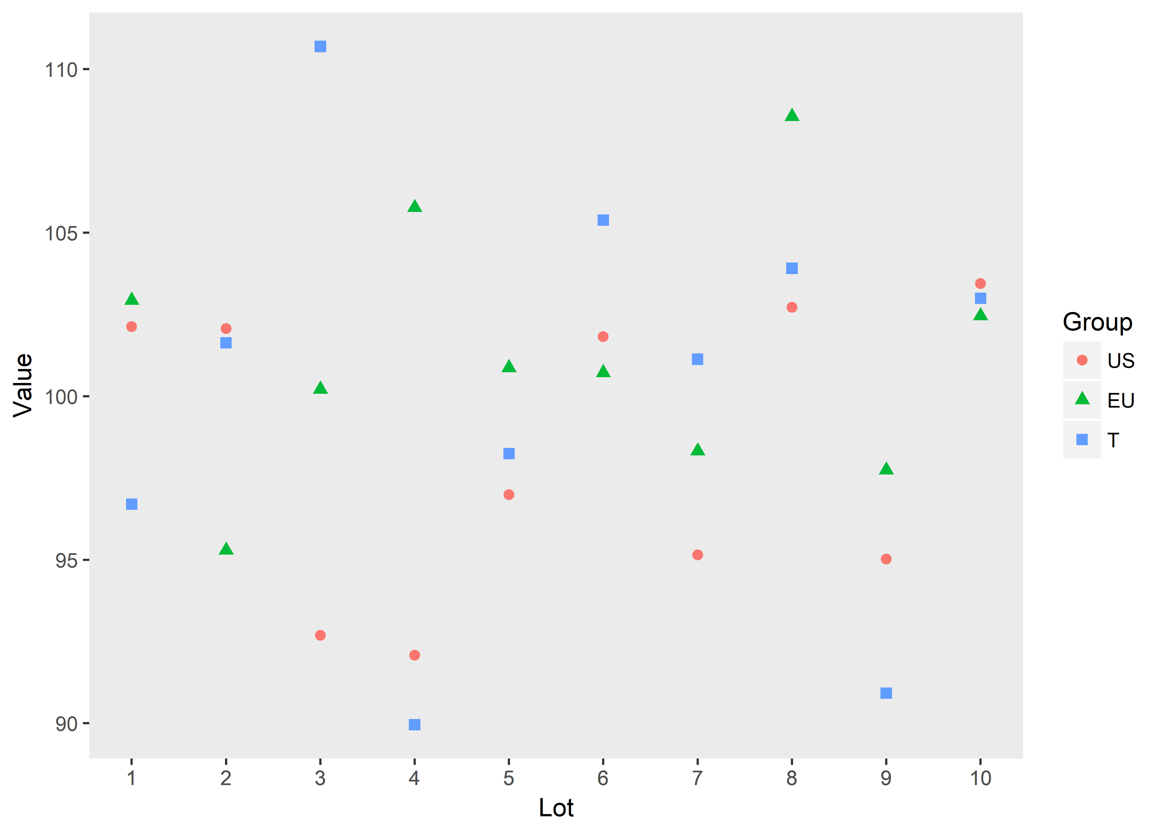

**Table 2. The results of pairwise comparison approach vs. Simultaneous confidence interval approach.**

|  |  |  |  |  |  |  |  |  |  |
| --- | --- | --- | --- | --- | --- | --- | --- | --- | --- |
| **Pairwise comparison approach** | | | | | **Simultaneous confidence interval approach** | | | | |
| **Comparison** | **Mean difference** | **90% CI** | **EAC margin1** | **Equivalence Test** | **Method** | **Fiducial probability** | **Type 1 90% CI** | **Type 2 90% CI** | **Simultaneous**  **similarity** |
| EU vs. US | -2.87 | (0.42,5.33) | 5.01 | Fail | Original | 0.92 | (-4.51, 4.51) | (-4.79, 4.79) | Pass |
| US vs. T | -1.74 | (-0.72,4.20) | 5.01 | Pass | Integrated | 0.92 | (-4.51, 4.51) | (-4.84, 4.84) | Pass |
| EU vs. T | 1.13 | (-6.08,3.82) | 10.09 | Pass | Least Favorable | 0.79 | NA | (-4.15, 4.15) | Fail |

1, Similarity margin = 1.5*sigma(Ref)



From Table 2, the pairwise comparison approach failed to reject one of the null hypotheses that the two reference drugs are not similar enough (EU vs. US, 90% CI: 0.42-5.33, exceed the EAC margin=5.01). While two out of the three simultaneous confidence interval methods had fiducial probabilities calculated higher than 0.9 (0.92 for both original version and integrated version), and the corresponding two versions of confidence intervals lie within the simultaneous margin, thus could successfully reject all three hypotheses in (3), (4) and (5), i.e., conclude similarity among US, EU, and T. However, the least favorable version failed to conclude the similarity (fiducial probability=0.79). Further discussion of the new methods’ performance under different parameter settings can be found in the simulation studies of the following section.

**4. Simulation Studies**

Simulation studies were used to assess the performance of the proposed methods. For parameter specification, assume the three drugs, R1, R2 and T follow normal distributions with equal variance. standard deviations(2/1.5, 2, 4, 6, 8, 10, 12, 14) ere, margin. wasstandard deviation, 1000 We discuss two scenarios where the means difference between the two reference drugs R1, R2 are closer than to the test drug T, as well as the other way around.

1)

The expectations of the three drugs R1, R2 and T were set to be 99, 100 and 101, respectively. For summarization of the simulation results, we calculated the rate of rejecting all three hypotheses for each method (i.e., power, if above the margin or type I error, if on the margin), and the coverage rate of each simultaneous CI. Besides, the rate of rejecting all three hypotheses by the pairwise comparison approach was also calculated for comparison with the proposed methods. The summary results are shown in Table 3. We see all methods control the type I error no larger than the nominal level of 0.1. Two proposed simultaneous confidence interval approach (original and integrated version), performed significant better than the pairwise comparison method. For example, while standard deviation equals 8, the first two simultaneous confidence interval approach had power 0.74 and 0.72, respectively, much higher than the pairwise comparison method, which had overall power only 0.65, and the corresponding simultaneous confidence intervals, (- ${\hat{∆}}_{1-α}^{1},{\hat{∆}}_{1-α}^{1}$) and (- ${\hat{∆}}_{1-α}^{2},{\hat{∆}}_{1-α}^{2}$) had 100% coverage rate of the true means.

The least favorable version, had the lowest power thus should be avoided in practice.

**Table 3. Simulation statistics of different methods ($μ_{R_{1}}=99, μ_{R_{2}}=100, μ_{T}=101$).**



Figure 2 further illustrates the comparison of power between pairwise comparison and the three simultaneous confidence interval methods. The purple line represents the pairwise comparison, and the rest three lines represents the three versions of simultaneous confidence interval approach (original, integrated and least favorable version). The x-axis represents the sample standard deviation which takes values from 1.33 to 14, where the red-dotted line (SD=1.33) is the rejection margin under EAC. The y-axis represents the empirical power based on 1000 replications. It indicates that the original (orange line) and integrated (green) version of simultaneous confidence interval approach have significantly larger power than the pairwise comparison (purple), and the superiority maintains as the standard deviance varies. While the least favorable version (blue) performs the worst among the four methods.

**Figure 2. Simulation performance of different methods ($μ_{R_{1}}=99, μ_{R_{2}}=100, μ_{T}=101$).**

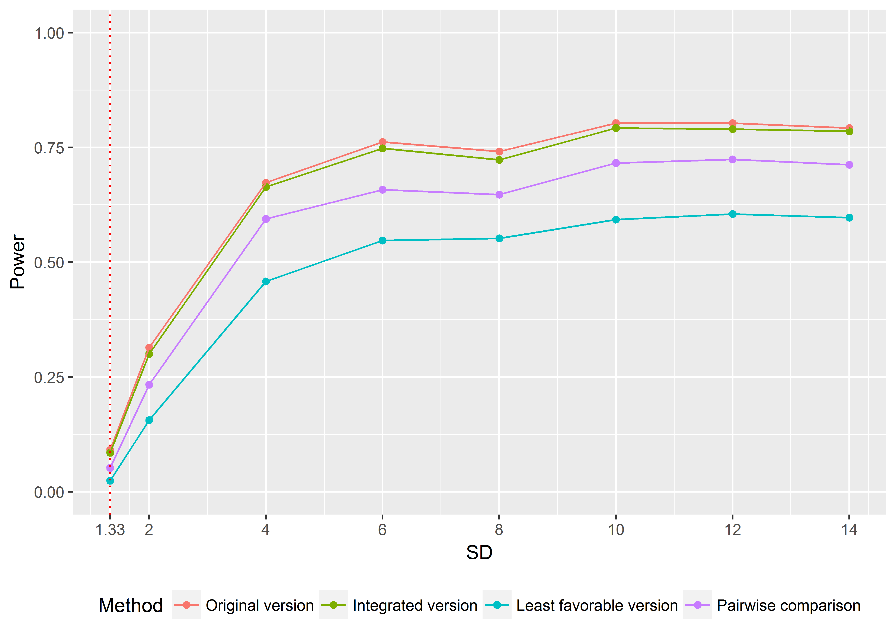



The expectations of the three drugs R1, R2 and T were set to be 99, 101 and 100, respectively.

**Table 4. Simulation statistics of different methods ($μ_{R_{1}}=99, μ_{R_{2}}=101, μ_{T}=100$).**



**Figure 3. Simulation performance of different methods ().**

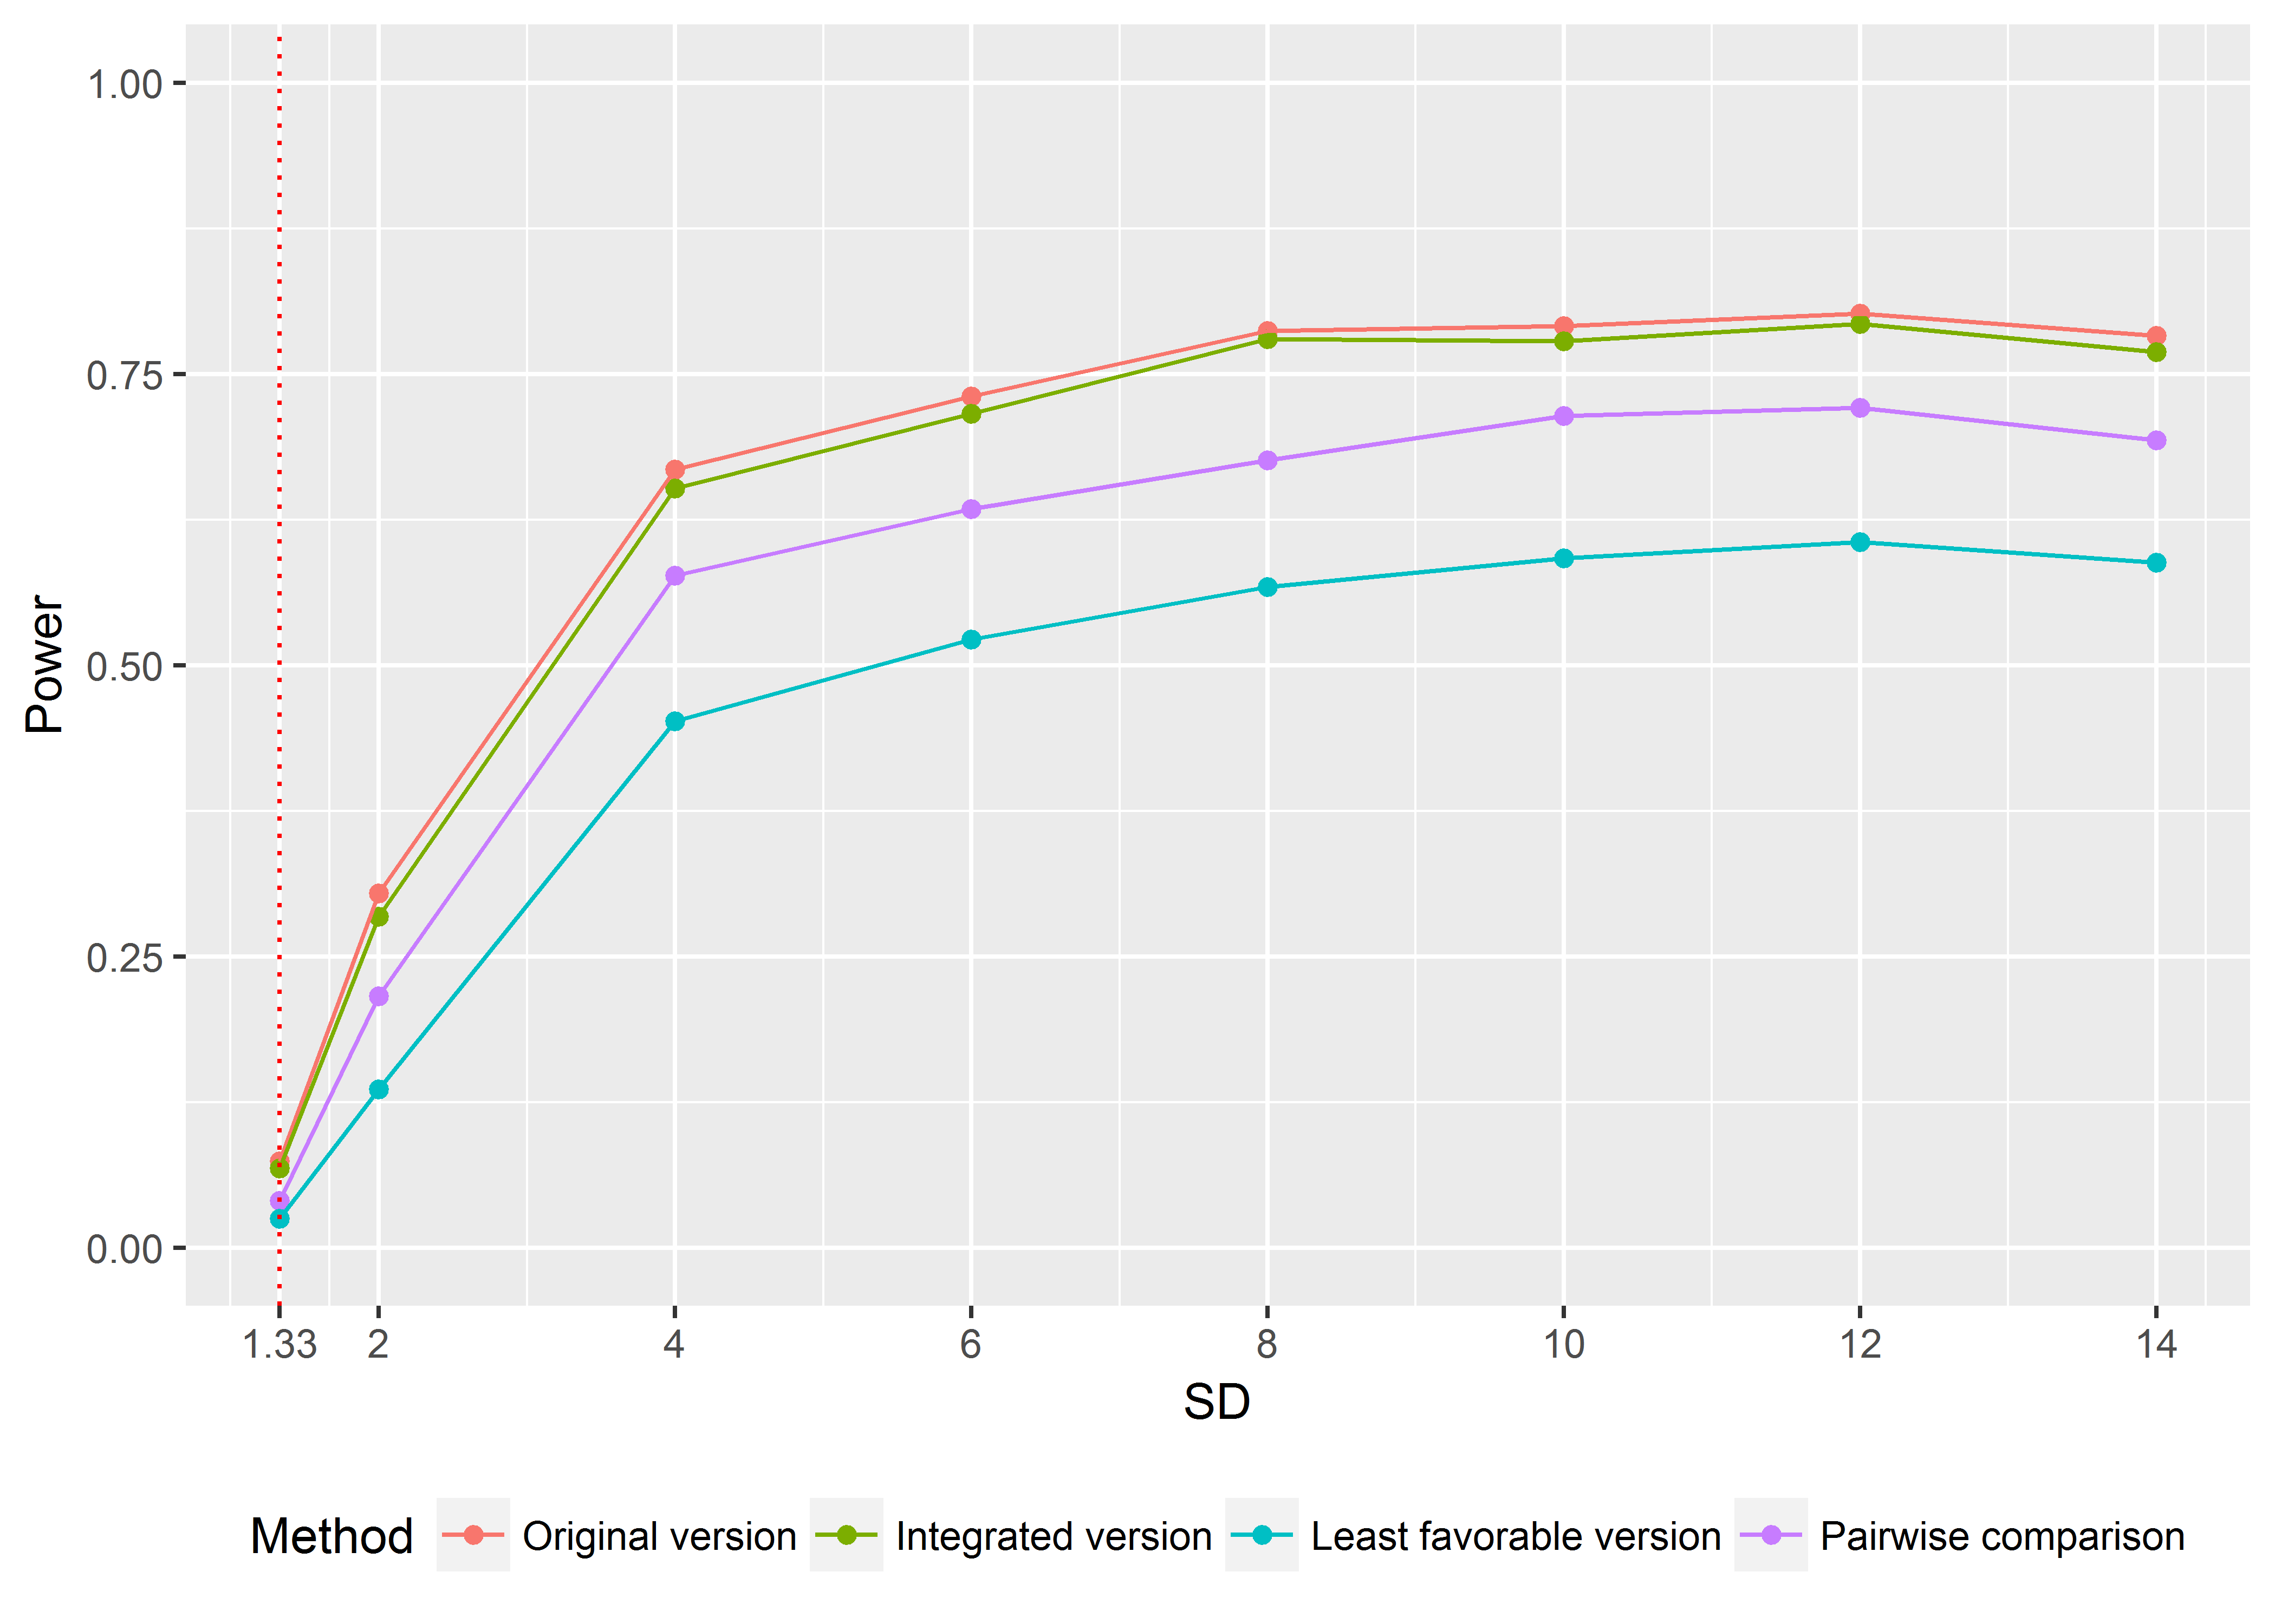



**5. Concluding Remarks**

For the application of the proposed methods, required sample size can be obtained by numerical simulation. The simulation studies showed that the proposed first and second version of fiducial probability and the corresponding restricted simultaneous CIs perform well with larger power compared to the pairwise comparison approach.

**References**

FDA (2017). Guidance for Industry – Statistical Approaches to Evaluate Analytical Similarity. Food and Drug Administration, Silver Spring, Maryland, September, 2017.

Fisher RA. The fiducial argument in statistical inference. Annals of Human Genetics 1935; 6(4):391–398.

Jiayin Zheng, Shein‐Chung Chow, Mengdie Yuan. On Assessing Bioequivalence and Interchangeability between Generics Based on Indirect Comparisons. Statistics in Medicine, 2017, 36(19): 2978-­‐2993. DOI: 10.1002/sim.7326